**SOLOMON'S EVANGELICAL LUTHERAN CHURCH**

**4856 WAYNE ROAD**

**CHAMBERSBURG, PA 17202**

1. **267-2266**

Email: info@solomonslutheran.org

Web Site:[www.solomonslutheran.org](http://www.solomonslutheran.org)

Facebook Search: Solomon’s Lutheran Facebook



*"Solomon's Evangelical Lutheran Church, following the example of Jesus Christ, seeks to live in the confidence and fullness of God's grace; to preach the Good News boldly and truthfully; to support and serve others in faith; to work in harmony with all creation."*

**Twenty-Third Sunday After Pentecost**

**November 8, 2020**

**NOVEMBER 8, 2020**

**23RD SUNDAY AFTER PENTECOST**

*Today the prophet Amos calls for justice to roll down like waters. Paul urges us to encourage one another with the promised coming of the Lord. Jesus tells the parable of the wise and foolish bridesmaids. Surrounded by the faithful of every time and place, we celebrate Christ’s coming in our midst in the word of life and the feast of victory—the marriage feast of the lamb.*

**Greetings and Announcements**

**Prelude**

**Confession and Forgiveness**

Blessed be the holy Trinity, ☩ one God,

in whose image we are made,

who claims us and calls us beloved.

**Amen.**

*Silence is kept for reflection*

Holy One,

**we confess that we are not awake for you.**

**We are not faithful in using your gifts.**

**We forget the least of our siblings.**

**We do not see your beautiful image in one another.**

**We are infected by sin**

**that divides your beloved community.**

**Open our hearts to your coming,**

**open our eyes to see you in our neighbor,**

**open our hands to serve your creation. Amen.**

Beloved, we are God’s children,

and Jesus, our Beloved, opens the door to us.

Through ☩ Jesus you are forgiven,

by Jesus you are welcome,

in Jesus you are called to rejoice!

Let us live in the promises prepared for us

from the foundation of the world.

**Amen.**

**Gathering Song*O God, Our Help in Ages Past* (ELW 632)**



**Greeting**

The grace of our Lord Jesus Christ, the love of God,

and the communion of the Holy Spirit be with you all.

**And also with you.**

**Canticle of Praise**

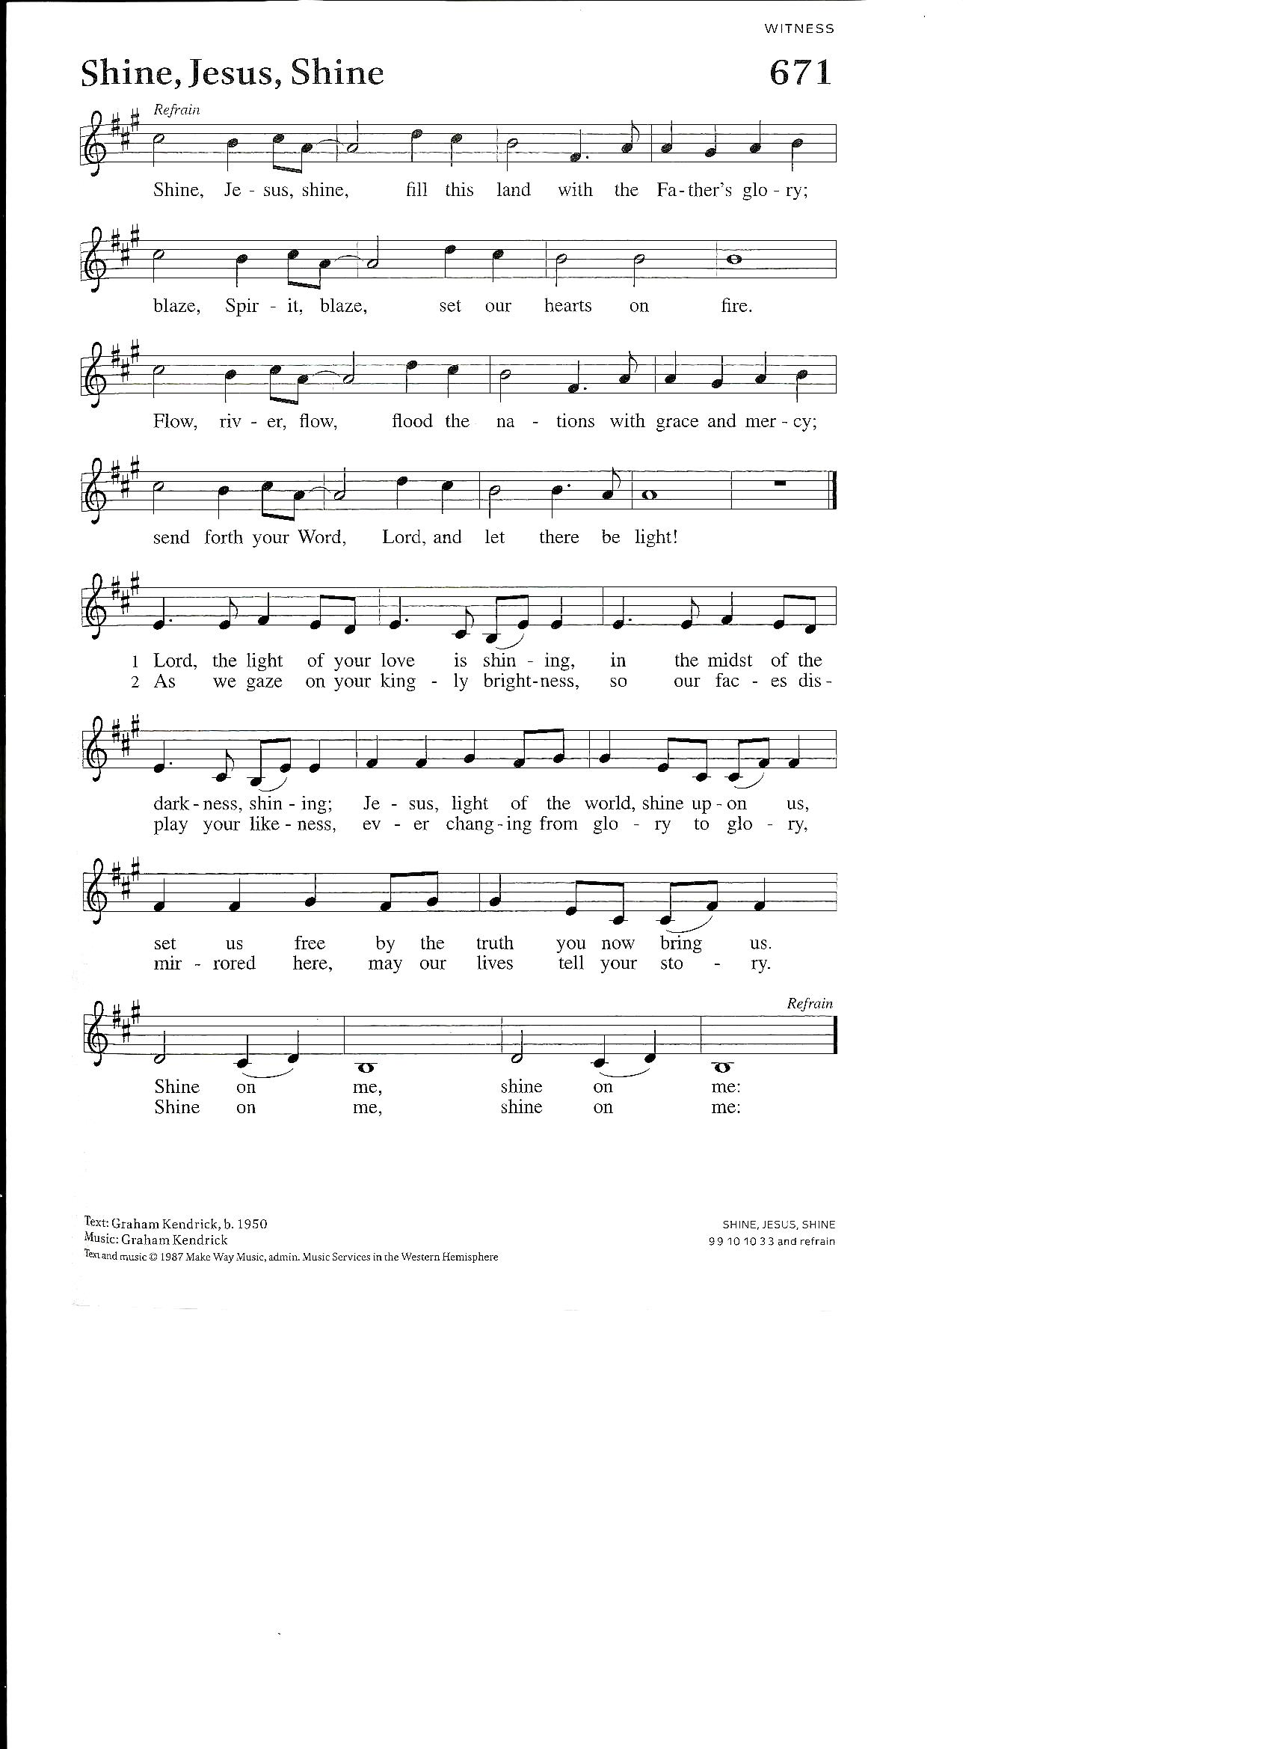

Reprinted under OneLicense #A-719004. All rights reserved.

**Prayer of the Day**

Let us pray.

**O God of justice and love, you illumine our way through life with the words of your Son. Give us the light we need, and awaken us to the needs of others, through Jesus Christ, our Savior and Lord. Amen.**

**First Reading: Amos 5:18-24**

*In the days of Amos, people thought that the day of the LORD would be a time of great victory, but Amos announced that it would be a day of darkness, not light. He said liturgy is no substitute for obedience. The LORD demands justice and righteousness in the community.*

A reading from Amos.

18Alas for you who desire the day of the Lord!  
  Why do you want the day of the Lord?  
 It is darkness, not light;  
  19as if someone fled from a lion,  
  and was met by a bear;  
 or went into the house and rested a hand against the wall,  
  and was bitten by a snake.  
 20Is not the day of the Lord darkness, not light,  
  and gloom with no brightness in it?  
 21I hate, I despise your festivals,  
  and I take no delight in your solemn assemblies.  
 22Even though you offer me your burnt offerings and grain offerings,  
  I will not accept them;  
 and the offerings of well-being of your fatted animals  
  I will not look upon.  
 23Take away from me the noise of your songs;  
  I will not listen to the melody of your harps.  
 24But let justice roll down like waters,  
  and righteousness like an ever-flowing stream.

The word of the Lord.

**Thanks be to God.**

**Psalm: Psalm 70**

*(Read responsively between men and women, beginning with the men)*

1Be pleased, O God, to de- | liver me;  
  O Lord, make | haste to help me.  
 2**Let those who seek my life be put to shame | and confounded;**  
  **let those who take pleasure in my misfortune draw back and | be disgraced.**   
 3Let those who say to me “Aha!” and gloat | over me  
  turn back because | of their shame.  
 4**Let all who seek you rejoice and be | glad in you;**  
  **let those who love your salvation say forever, “Great | is the Lord!”**  
 5But as for me, I am poor and needy; come to me quick- | ly, O God.  
  You are my helper and my deliverer; O Lord, | do not tarry.

**Second Reading: 1 Thessalonians 4:13-18**

*Some of the Thessalonians are worried that dead Christians will be excluded from the resurrection to eternal life when Christ comes again. Paul reassures them with the word of hope that all Christians, living or dead, will be raised into everlasting life with Christ.*

A reading from 1 Thessalonians.

13We do not want you to be uninformed, brothers and sisters, about those who have died, so that you may not grieve as others do who have no hope. 14For since we believe that Jesus died and rose again, even so, through Jesus, God will bring with him those who have died. 15For this we declare to you by the word of the Lord, that we who are alive, who are left until the coming of the Lord, will by no means precede those who have died. 16For the Lord himself, with a cry of command, with the archangel’s call and with the sound of God’s trumpet, will descend from heaven, and the dead in Christ will rise first. 17Then we who are alive, who are left, will be caught up in the clouds together with them to meet the Lord in the air; and so we will be with the Lord forever. 18Therefore encourage one another with these words.

The word of the Lord.

**Thanks be to God.**

**Gospel Acclamation**



**Gospel: Matthew 25:1-13**

The holy gospel according to Matthew.

**Glory to you, O Lord.**

*Jesus tells a parable about his own second coming, emphasizing the need for readiness at all times.*

[Jesus said to the disciples:] 1“Then the kingdom of heaven will be like this. Ten bridesmaids took their lamps and went to meet the bridegroom. 2Five of them were foolish, and five were wise. 3When the foolish took their lamps, they took no oil with them; 4but the wise took flasks of oil with their lamps. 5As the bridegroom was delayed, all of them became drowsy and slept. 6But at midnight there was a shout, ‘Look! Here is the bridegroom! Come out to meet him.’ 7Then all those bridesmaids got up and trimmed their lamps. 8The foolish said to the wise, ‘Give us some of your oil, for our lamps are going out.’ 9But the wise replied, ‘No! there will not be enough for you and for us; you had better go to the dealers and buy some for yourselves.’ 10And while they went to buy it, the bridegroom came, and those who were ready went with him into the wedding banquet; and the door was shut. 11Later the other bridesmaids came also, saying, ‘Lord, lord, open to us.’ 12But he replied, ‘Truly I tell you, I do not know you.’ 13Keep awake therefore, for you know neither the day nor the hour.”

The gospel of the Lord.

**Praise to you, O Christ.**

**Sermon Pastor Bill**

**Hymn of the Day*Wake, Awake, for Night Is Flying* (ELW 436)**



Please join me as we confirm our faith together in the words of the Apostles' Creed.

**Creed**

**I believe in God, the Father almighty,**

**creator of heaven and earth.**

**I believe in Jesus Christ, God’s only Son, our Lord,**

**who was conceived by the Holy Spirit,**

**born of the virgin Mary,**

**suffered under Pontius Pilate,**

**was crucified, died, and was buried;**

**he descended to the dead.**

**On the third day he rose again;**

**he ascended into heaven,**

**he is seated at the right hand of the Father,**

**and he will come to judge the living and the dead.**

**I believe in the Holy Spirit,**

**the holy catholic church,**

**the communion of saints,**

**the forgiveness of sins,**

**the resurrection of the body,**

**and the life everlasting. Amen.**

**Prayers of the Church** *(Please respond.)*

*P: Hear us, O God.* ***C: Your mercy is great.***

**Peace**

The peace of Christ be with you always.

**And also with you.**

**Great Thanksgiving**

The Lord be with you.

**And also with you.**

Lift up your hearts.

**We lift them to the Lord.**

Let us give thanks to the Lord our God.

**It is right to give our thanks and praise.**

**Preface**

It is indeed right, our duty and our joy,

that we should at all times and in all places

give thanks and praise to you, almighty and merciful God,

through our Savior Jesus Christ;

who on this day overcame death and the grave,

and by his glorious resurrection opened to us the way of everlasting life.

And so, with all the choirs of angels,

with the church on earth and the hosts of heaven,

we praise your name and join their unending hymn:

**Holy, Holy, Holy**

C:\Users\Sally\AppData\Local\Microsoft\Windows\INetCache\Content.Word\Holy, Holy, Holy (Argentine) Santo, santo, santo (Melody).tif

**Thanksgiving at the Table**

In the night in which he was betrayed,

our Lord Jesus took bread, and gave thanks;

broke it, and gave it to his disciples, saying:

Take and eat; this is my body, given for you.

Do this for the remembrance of me.

Again, after supper, he took the cup, gave thanks,

and gave it for all to drink, saying:

This cup is the new covenant in my blood,

shed for you and for all people for the forgiveness of sin.

Do this for the remembrance of me.

**Lord’s Prayer**

Gathered into one by the Holy Spirit, let us pray as Jesus taught us.

**Our Father, who art in heaven,**

**hallowed be thy name,**

**thy kingdom come,**

**thy will be done,**

**on earth as it is in heaven.**

**Give us this day our daily bread;**

**and forgive us our trespasses,**

**as we forgive those**

**who trespass against us;**

**and lead us not into temptation,**

**but deliver us from evil.**

**For thine is the kingdom,**

**and the power, and the glory,**

**forever and ever. Amen.**

**Invitation to Communion**

There is a place for you at the banquet.

Come and feast at Jesus’ table.

**Communion**

*Continuous – Please continue down center aisle at direction of the usher, maintaining your distance and keeping your mask on. Move your mask to eat the bread and drink the wine. Please place your empty communion cup in the basket. Return to your seat with your mask on.*

**Communion Blessing**

The body and blood of our Lord Jesus Christ strengthen you and keep you in his grace. **Amen.**

**Prayer after Communion**

Lord Jesus,

in this simple meal you have set a banquet.

Sustain us on the journey,

strengthen us to care for the least of your beloved children,

and give us glad and generous hearts

as we meet you on the way.

**Amen.**

**Blessing**

The Lord bless you and keep you.

The Lord’s face shine on you with grace and mercy.

The Lord look upon you with favor and ☩ give you peace.

**Amen.**

**Sending Song*Lift Every Voice and Sing* (ELW 841)**



**Dismissal**

Beloved of God,

go in peace to love and serve the Lord.

**Thanks be to God.**

**Silent Prayer**

**Postlude**

From sundaysandseasons.com. Copyright © 2020 Augsburg Fortress. All rights reserved.

Permission to podcast/stream the music in this service obtained from ONE LICENSE, #A-719004. All rights reserved.

**SERVING TODAY**

Pastor – Rev. Bill Nienstedt

Home Phone Number: 717-264-3757

Email Address: [Pastor@solomonslutheran.org](mailto:Pastor@solomonslutheran.org)

Church Office Email Address: [office@solomonslutheran.org](mailto:office@solomonslutheran.org)

Organist – Doug Mummert

Head Usher – Kathy Bowen

Acolyte – Rebekah Aldrich

Lector – Patricia Yetter

Attendance last Sunday – 35

**Stewardship Thought – November 8, 2020** (23rdSunday after Pentecost, Proper 27, Year A)  
*“But let justice roll down like waters, and righteousness like an ever-flowing stream.”***– Amos 5:24**

Through the prophet Amos, God condemns hollow displays of religiosity. What God desires is action –justice and righteousness – ever-flowing from the hearts of those who love the Lord. Act on your thankfulness this week by working for justice in your community.

**ANNOUNCEMENTS**

**The altar flowers** this morning are placed to the Glory of God in honor of Jared and Emma Mummert, married at Solomon’s yesterday given by Mom and Dad.

**Welcome Visitors!** We welcome you to our worship service. We hope your visit with us will be a time of blessing. If you have any concerns, please talk to the Head Usher. We invite you to worship with us again!

**Prayer requests** for the following persons: ***Emma and Jared Mummert who were married Saturday at Solomon’s, Jerry and Esther Schultz,*** *Linda Small Naus, Nancy Marshall, Lee Locke, Joan and David Likeness, Darrell Veilleux, Denise Bowen, Jeffrey Wenger, Jack Hess, Sylvia Wenger, Barbara Socks, Patsy Wagner, Anne English, Bill Sellers, Millie Kulkusky, Karen Sanders, Jackson, Bonnie Hudson.* If anyone has a prayer request, please call Janice McEntire. **Note:** At the beginning of each month, the Prayer Request List will start anew. If you would like to remain listed on the next month’s list, or if you would like to have your name removed from the list before the end of the month, please call the office.

**Power Packs**: With school back in session, the Power Packs program has now resumed. Currently, eight families have been identified at New Franklin Elementary School in need of food assistance. You can donate vegetable or fruit cups like last year. Donations of cash are also welcome if you are unable to shop or attend church due to the pandemic.

**Candy Making**: It’s the return of candy making at Solomon’s! We will be working on Monday, Tuesday and Wednesday. We will set-up on Sunday Nov. 8th. At 6:30 a.m. we need people to stir chocolate during the melting process. At 8:00 a.m. we need volunteers to dip chocolate into paper cups. We will have stations spaced throughout the gym in small groups. You will need to wear a mask, gloves and hat/hairnet. (Gloves and hairnets will be provided. Bring your own mask and hat.) Pick-up dates will be Saturday Nov. 14th between 10 am and 12:00 pm and Sunday Nov. 15th after Church.

**Notice of Congregational Meeting, November 22, 2020.** The regular annual congregational meeting will take place immediately following worship on Sunday, November 22, 2020. The primary purpose of the meeting is to elect new council members and approve the 2021 annual operating budget. If you wish to vote but not attend worship, the meeting will begin at approximately 10:20 a.m.  We will require a quorum to vote so your attendance is encouraged. We are making improvements to the technology in the sanctuary and we hope to offer a video teleconference of the meeting. Please note that you must be present to cast a ballot as the Solomon’s constitution does not allow for absentee ballots. Please watch for a letter and the proposed budget being sent by US Mail to all member families.

**Thanksgiving Worship Service**

**Sunday, November 22nd at 9:30 a.m.**

We will celebrate Thanksgiving and give thanks to God for all our blessings in Sunday worship on this day. We will bring them forward with the offering and the communion elements as a visible sign of God’s abundant gifts.

**Salvation Army Bell Ringing** will take place on Saturday, November 28 in front of the Butcher Shoppe from 8:00 am to 2:00 pm. Social Ministry is in need of 12 volunteers (2 volunteers each hour). A signup sheet is on the bulletin board in the Sunday School room.  Any questions, please call or email Edna, 717-352-4392 or [bernedna@centurylink.net](mailto:bernedna@centurylink.net) .  Let's all rally and help the Salvation Army out during this difficult time.

**Congregation Council** will meet on Monday, November 9 at 7 PM in the Fellowship Center.

**Bulletin Announcement Forms** are located in both pamphlet racks. Please submit all bulletin announcements to by the Wednesday prior to the Sunday for inclusion in the bulletin.

**Council Minutes, Monthly Financial Statement and Committee Minutes** are available in the library for anyone to read.

**2020 Poinsettia Order Form**

Anyone desiring to remember a loved one or honor someone with Christmas Poinsettias is asked to fill out the following form and mail it to the church office or put it in the collection plate along with a check made payable to Solomon’s Lutheran Church, marked “Poinsettia Order.” Deadline to order a **red or marble** (pink & white)poinsettia is November 29. Cost is $9.60 each.

***The Christmas Poinsettias in Memory and Honor of Family and Friends***

***have been donated by:***

______________________________________________

*(name)*

Red _____ Marble _____

Total amount enclosed ________ Total Poinsettias ordered _____

In memory of ______________________________________________________

In memory of ______________________________________________________

In honor of _______________________________________________________

In honor of _______________________________________________________

Poinsettias will be in the church on December 24. If you will not be attending church on Dec 24, you can make arrangements to pick up your flowers by calling the church office.

**NOVEMBER 8, 2020**

**TWENTY-THIRD SUNDAY**

**AFTER PENTECOST**

***Be alert and be glad for the Lord is coming.***

**DAILY BIBLE READINGS**

*These passages are related to the Lectionary texts for this Sunday.*

|  |  |  |
| --- | --- | --- |
| **Sunday** | **Matthew 25:1-13** | **A parable of the ten bridesmaids** |
| **Monday** | **Amos 5:18-24** | **What the Lord requires** |
| **Tuesday** | **1 Thessalonians 4:13-18** | **The coming of the Lord** |
| **Wednesday** | **Joshua 24:1-3a, 14-25** | **The tribes renew the covenant** |
| **Thursday** | **Psalm 78:1-7** | **Tell the children God’s word** |
| **Friday** | **Luke 21:29-37** | **Be always on the watch** |
| **Saturday** | **Psalm 70** | **God is wonderful** |
| **Sunday** | **Matthew 25:14-30** | **Parable of the talents** |

**SCRIPTURE VERSE FOR THIS WEEK**

Let all who seek you rejoice and be glad in you. Let those who love your salvation say evermore, “God is great!” **Psalm 70:4 (NRSV)**

**PRAYERS AND BLESSING**

**A Prayer for the Week:**

Righteous God, help us to be ready for the time Christ will come again to judge the living and the dead and to anticipate the end of the age with joy. Amen.

**Mealtime Prayer:**

Dear God, help us to receive this food with thanksgiving and to serve those less fortunate with acts of love and service. Amen.

**A Blessing to Give:**

May the God who promises you the great banquet feast bless you with peace and joy now and always.

**CARING CONVERSATIONS**

Discuss in your home or small group:

* Tell or think about something that you do with focused attention.
* How does paying attention help you do your best?
* Jesus wants his followers to stay alert and be ready for his coming. How is this

important to you and to others?

**HYMN OF THE WEEK**



*God of Grace and God of Glory*

**DEVOTIONS**

*Read:* Matthew 25:1-13.

This parable seems harsh. We might think we are to have mercy on the foolish and not lock them out. A more merciful approach is evident in the next chapter when Jesus’ leadership team of disciples falls asleep while Jesus prays in the garden (26:36-46). Jesus chastises them without a sense of rejection. In this parable the church is reminded to live with the final victory of God in Christ in view. It is to impact our daily lives as we wait for Christ’s second coming. However, unless there is a particular experience of suffering, we tend to live without paying much attention to Christ’s coming again. Jesus is alerting his followers to the importance of watchfulness of the times and readiness to act faithfully at any given moment. That is when the church blesses, serves with justice, and offers salvation in Jesus’ name. How might a conscious awareness of Christ’s victory and return to “judge the living and the dead” (Apostles’ Creed), impact your daily conduct?

*Pray:* **Come Lord Jesus, strengthen our lives of faith that we may anticipate your coming again with joy and serve our neighbor in love. Amen.**

**SERVICE**

According to Amos, worship without acts of justice for the needy is meaningless to God. During and after a worship service, take time to think about how God’s acts of love and mercy for you and all humanity lead you to do acts of kindness and love for others.

**RITUALS AND TRADITIONS**

The foolish bridesmaids in the parable did not have additional oil for their lamps. The light in their lamps could not shine. They were not ready. It is important to be ready and let the light of Jesus’ love shine. We can do this by being ready to do God’s work everyday. One way to be ready is to pray for others, read scripture, and bless others. Use this blessing daily during this week: **May the light of Christ shining through you show your readiness to do God’s work.**

© 2019 Milestones Ministry, LLC. All rights reserved.